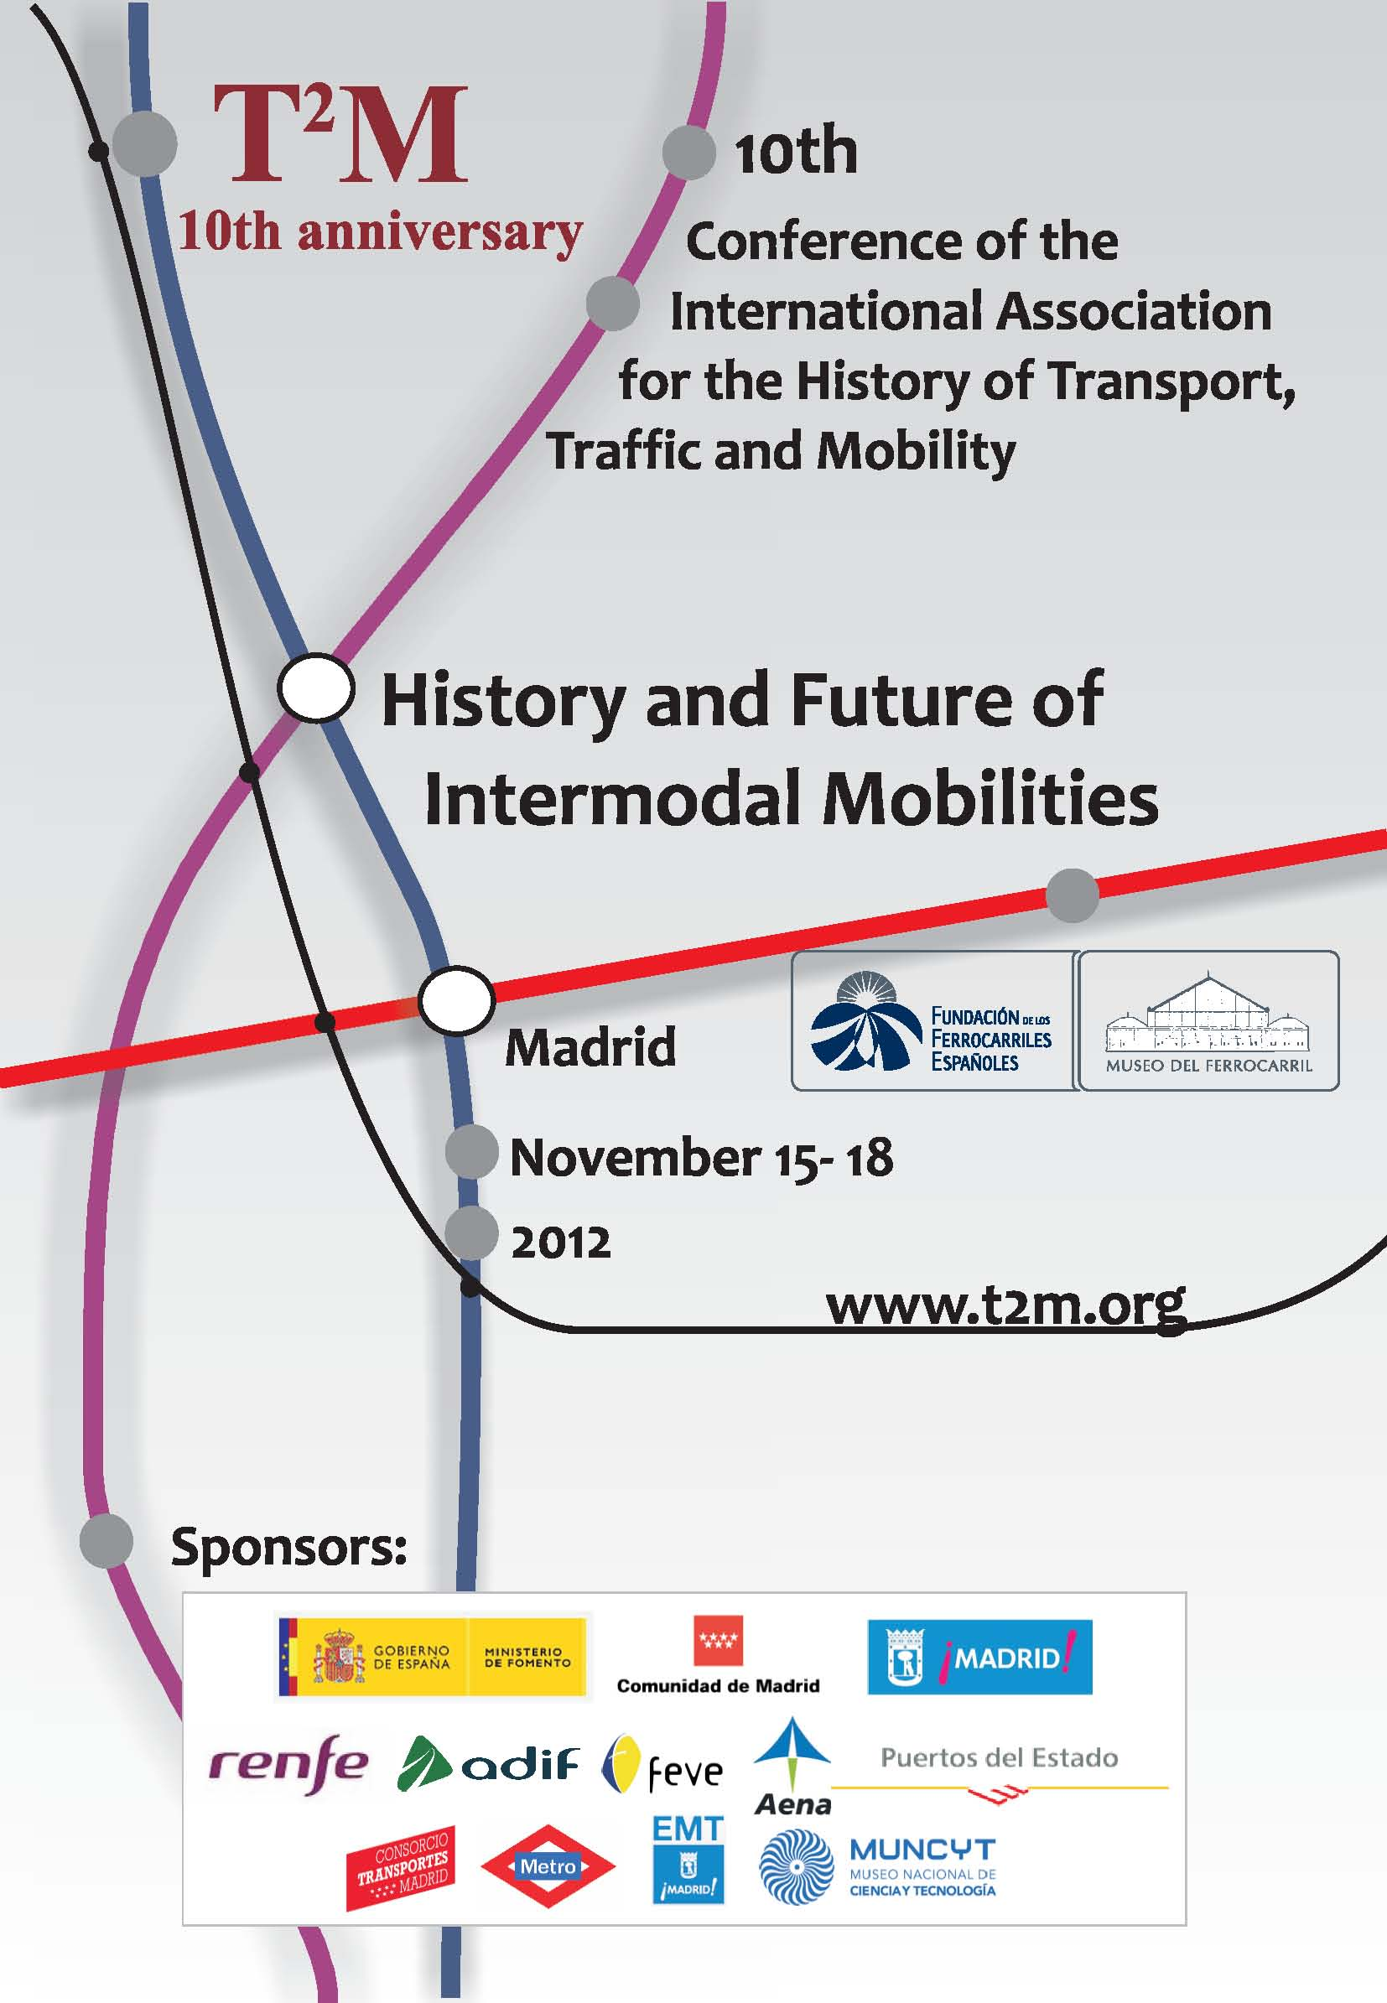

## Tenth annual Conference of the International Association

## for History of Transport, Traffic and Mobility - T2M

## Madrid, November 15 -18, 2012

## Program

## Madrid RailwayMuseum - Paseo de las Delicias, 61 – 28045, Madrid

**Thursday, 15**

|  |  |
| --- | --- |
| **9,00-13,00** | **Meeting of the Executive Committee of T2M (Saloon Coach).** |
| **13,30-16,00** | **Meeting of the Editorial Board of JTH (Saloon Coach).** |
| **16,00-17,00** | **Meeting of the Editorial Board of T2M Annual Yearbook (Saloon Coach).** |
| **13,00-17,00** | **Registration** (Conference Center – Mansard Room). |
| **18,00** | **Departure of pedestrian route guided from the Madrid Railway Museum until Spanish Railways Foundation headquarters at Fernán Núñez Palace (C/ Santa Isabel, 44 – 28102, Madrid).** |
| **18,30** | **Welcome to Public Lecture (Fernán Núñez Palace – Spanish Railways Foundation).** |
| **19,00** | **Public Lecture (Fernán Núñez Palace – Spanish Railways Foundation).**  **"Spanish Railways' Original Sins: Planning and Financing Problems in the Nineteenth Century"**  **Gabriel Tortella Casares, Professor emeritus, University of Alcalá de Henares.** |
| **20,00** | **Official Reception at Fernán Núñez Palace – Spanish Railways Foundation.**  **Perfomance by Chorus of Spanish Railways Foundation.** |
|  |  |

**Friday, 16**

|  |  |
| --- | --- |
| **9,00-9,15** | **General Information** (Conference Hall). |
| **9,15-10,00** | **Plenary Lecture** (Conference Hall).  **“Capital finance, finance capital and historical changes in the structure of transportation systems, 1840- present” Jim Cohen**, Professor emeritus, The City University of New York. |

**10,15-11,45 Conference Hall**

**History of Intermodal Transportation**

**Chair: Javier Vidal Olivares** (University of Alicante)

**Alberte Martínez / Jesús Mirás** (University of A Coruña) *Late but not last. Changes in urban mobility in Spain, 1870-2010.*

**Emilie Cottet** (University of Savoy) *The intermodality in Savoy in the XIXth century: a choice or a necessity?*

**Hugo Silveira Pereira** (University of Porto) *Intermodality in Portugal: railways, trams and roads (1845-1899).*

**Patrick Sherry / Allison M. Bondanza / Briana Hedman** (University of Denver) *The United States History of Intermodal Transportation.*

**Stefano Maggi** (University of Siena) *Intermodality in Italy during the fascist period. A case study.*

**10,15-11,45 Talgo Classroom**

**Transcontinental Air Transport: The History and Future of Intermodality in Air Travel in the United States**

**Chair: Dominick A. Pisano** (National Air and Space Museum, Smithsonian Institution)

**Dorothy Cochrane** (National Air and Space Museum, Smithsonian Institution) *TAT Air and Rail Coast to Coast: Passenger Reports by Amelia Earhart, Anne Lindbergh and ”Real” people.*

**Dominick A. Pisano** (National Air and Space Museum, Smithsonian Institution) *Air-Rail Transportation Intermodality in the U.S.:*

*A Failure of Vision.*

**F. Robert van der Linden** (National Air and Space Museum, Smithsonian Institution) *Transcontinental Air Transport: Accidental Intermodality, 1929-1930.*

**10,15-11,45 Library Room**

**Madrid, Trains and the Culture(s) of Transportation**

**Chair: Benjamin Fraser** (The College of Charleston)

**Benjamin Fraser** (The College of Charleston) *The Speed of Signs: Train Graffiti in the Spanish Context.*

**Susan Larson** (University of Kentucky) *The Spanish Train as Poetic Muse.*

**Araceli Masterson-Algar** (Augustana College) *Digging Madrid: A Descent Into Madrid’s Subway Museum ‘Andén 0’.*

**10,15-11,45 Classroom of National Museum of Scienceand Technology**

**Transport and Tourism**

**Chair: Ramón Molina de Dios** (University of Balearic Islands)

**Fedorova Marina Yurievna** (Institute of Economics of the Karelian Research Centre of the Russian Academy of Sciences)

*Tourism planning in Russia: from the Soviet times to the present.*

**Bård Toldnes** *Tourism and camping in Norway before WW2.*

**Rodrigo Booth** (Pontifical Catholic University of Chile) *Walking the Frontier. Long-distance tourist trips in Araucania and the lakes of southern Chile (1877-1900).*

**11,45-12,15 Coffee break** (Conference Center – Mansard Room)

**12,15-13,30 Conference Hall**

**Freight Intermodal Transport**

**Chair: Andrea Giuntini** (University of Modena)

**Tood F. Carney** (Southern Oregon University) *Before the Box Changed the World: Anthropogenic “Friction” in North America Transportation from the American Civil War to the Second World War.*

**Jørgen Burchardt** (National Museum of Science and Technology - Danemark) *The pallet – the small revolution in freight transportation.*

**Keith Harcourt** (Historical Model Railway Society) *Unitisation, containerisation and the development of intermodal transport in the United Kingdom.*

**Margaret Ritchie** (Strathclyde University, Glasgow) *Barrels, Boxes and Workers: co-ordinated transport for fresh and cured fish and the mobile workforces of the British fishing industry.*

**Peter Cox** (University of Chester) *Between store and home: distributing consumer goods.*

**12,15-13,30 Talgo Classroom**

**Lost in the suburbs: airports and intermodality from airfield to Aerotropolis**

**Chair: Gordon Pirie** (Journal of Transport History)

**Teresa Crompton** (American University of Sharjah) *The struggle for Sharjah Airport: How the British achieved their aviation aims on the Trucial Coast in the interwar years.*

**Christopher Kopper** (University of Bielefeld) *Airports: The problems of planning and building large infrastructure projects.*

**Peter Lyth** (Nottingham University Business School) *Lost in space: British airports and the lack of good connections, 1920 to 2010.*

**Víctor Márquez** (Cornell University) *“The Construction of Limbo”: How history shaoed the post 9/11 "boundaries of uncertainty" in contemporary airports.*

**Robert Morley** (University of Saskatchewan) *Intermodality on the Screen: Examining Cinematic Depictions of London Airports in the 1930s.*

**12,15-13,30 Library Room**

**Waiting in the Port: Ports as Cultural Encounters**

**Chair: Hans-Liudger Dienel** (Berlin University of Technology)

**Massimo Moraglio** (TechnologyUniversity of Berlin) *The Port of Hamburg.*

**Maria Fernanda Rollo** (New University of Lisbon) The Port of Lisbon.

**12,15-13,30 Classroom of National Museum of Scienceand Technology**

**Transport and Heritage**

**Chair: Francisco Polo Muriel** (Madrid Railway Museum)

**Eduardo Romero de Oliveira** (Sao Paulo State University) *Crossing places and heritage transport.*

**Antonio Burgos / María Paz Sáez / Juan Carlos Olmo** (University of Granada) *Transport infrastructures from XIX century in the Southeast of Spain. A view from engineering and heritage.*

**Robert Lee** (University of Western Sydney) *An icon of intermodal mobility: the Sydney Harbourbridge.*

|  |  |
| --- | --- |
| **13,30-13,45** | **Conference Photo Shooting** (Central Exhibition Hall – Madrid Railway Museum). |
| **13,45-15,00\*** | **Lunch** (Labor Dining). |
| **15,00*-18,30** | **Excursions programmed** (Meeting Place: Main Entrance Madrid Railway Museum). **\*Attention, only for the excursion to Barajas airport (T4), the meeting hour will be at 14,20h in the Main Entrance Madrid Railway Museum.** |
| **19,30-21,00** | **Historic Train route for Madrid**(departure from DeliciasCercanías Station and arrival to Sol Cercanías Station -first stop optional- and AtochaCercanías Station -last stop-). |

**Saturday, 17**

**9,00-11,00 Conference Hall**

**Regional and Metropolitan Transport System**

**Chair: Massimo Moraglio** (Berlin University of Technology)

**Martin Schiefelbusch** (Nexus Institut für Kooperations management und interdisziplinäre Forschung, Berlin) *Getting your competitor on board - Intermodality issues in the Baltic Sea area.*

**Daniel Olisa** (Bayero University, Kano) *The Imperative of Inter-Modal Transport System in Nigeria: The Case Study of Asaba and Onitsha Transportation System.*

**Probo Hardini** (University of Leeds) *Indonesian cities: patterns of relationships between land use, transport development and mobility behavior.*

**Javier Aldecoa** (Regional Transport Consortium of Madrid) *The Madrid` Plan of Interchanges: 100 years of history.*

**Claudine Mulley / Corinne Moutou** (The University of Sidney) *The transport success in providing for the Olympics in Sydney, Australia: why was this not captured in future policy for public transport.*

**9,00-11,00 Talgo Classroom**

**Motorization and Road Transport (I)**

**Chair: José Luis García Ruiz** (Complutense University)

**Evangelia Chatzikonstantinou / Areti Sakellaridou** (National Technical University of Athens/Aristotle University of Thessaloniki)

*Discussing intermodality and promoting road construction in Greece during the Interbellum.*

**Sofia Alexia Papazafeiropoulou** (National Technical University of Athens) *The antagonism of railways and automobiles in Greece from 1930s to 1960s as a case of a controversial intermodality.*

**Kyle Shelton** (University of Texas, Austin) *Will the Rubber meet the Rail?: The Struggle for Intermodality in Houston, an Automobile City.*

**Christiane Katz** (RWTH Aachen University) *The Motorization of the German City Administrations before World War.*

**9,00-11,00 Library Room**

**Railway as a factor of intermodality and economic development (I)**

**Chair: Alberte Martínez López** (University of A Coruña)

**Daniel Seidenglanz / Flip Chvátal / KateřinaNedvědová** (Masaryk University, Brno) *The Czech Republic and Germany – railways in metropolitan regions.*

**Ariel Rodolfo Fuentes** (University of Buenos Aires) *Green Western Corridor: reconfiguration of Buenos Aires railway system.*

**Domingo Martín / Antonio García** (Regional Transport Consortium of Madrid) *Intermodality and its historic perspective in the suburban railway in the region of Madrid.*

**Login Law Lok-yin** (Chinese University of Hong Kong) *Connecting Asia and China: the Development of Tsimshatsui Transport Complex (1911-1941).*

**Eric A. Sibul** (Baltic Defence College, Tartu) *Nothing like it in the world! The Florida East Coast Railway’s Key West Extension.*

|  |  |
| --- | --- |
| **11,00-11,30** | **Coffee break** (Conference Center – Mansard Room) |

**11,30-13,30 Conference Hall**

**Cycling History and Cycling Policies (I)**

**Chairs: Anne-Katrin Ebert**(Technical Museum of Vienna) **Manuel Stoffers**(University of Maastricht) **Hans Buiter**(ANWB, The Hague)

**Esther Anaya / Santiago Gorostiza (**Universidad Autónoma de Madrid / Universidad Complutense de Madrid) *Sources for the history of cycling mobility in Spain in the 20th Century.*

**Hans Buiter** (Association Historian at the Dutch Tourist Association) *The bicycle renaissance of the 1970s in the Netherland*

**Peter Cox** (University of Chester) *Theory and Method in Cycling Research.*

**Anne-Katrin Ebert** (Technical Museum of Vienna) *In Times of Crisis: The Bicycle’s Fate in Germany and the Netherlands after WWII reconsidered.*

**Martin Emanuel** (Royal Institute of Technology, Stockholm) *The “Bicycle Renaissance” Cut Short: Bicycle Planning and Appraisal of the Bicycle in Stockholm, 1970–1985.*

**11,30-13,30 Talgo Classroom**

**Motorization and Road Transport (II)**

**Chair: Gunter Heinickel** (Technical University of Berlin)

**Florian Wöltering** (RWTH Aachen University) *The Growing Importance of the Intermodal Passenger Transport for the Car Rental Business in Germany since World War 2.*

**José Barros** (New University of Lisbon) *The automobiles in the road public transports in Portugal in the beginning of the 20th century. Connections and disconnections.*

**O. O. Olubomehin / B. Yussuf / O. B. Oukonowo** (OlabisiOnabanjo University) *Luxurious Bus Enterprises and their Impact on the Nigerian Economy.*

**Panagiotis Zestanakis** (University of Creta) *“Penalizing speed”: Aspects of public anxiety about motorcyclism in 1980s Athens.*

**11,30-13,30 Library Room**

**Railway as a factor of intermodality and economic development (II)**

**Chair: Jesús Mirás Araujo** (University of A Coruña)

**Miguel Ángel Delgado/ Antonio García** (Regional Transport Consortium of Madrid) *Principe Pío Station: a history of intermodality in Madrid.*

**Martin Schiefelbusch /Sonja Ziener** (Nexus InstitutfürKooperationsmanagement und interdisziplinäreForschung, Berlin) *“Seamless travel” - International, intermodal and interactive rail fares across centuries.*

**Giovanni Mantovani** (Italian Association for Traffic and Transport Engineering) **Massimo Moraglio** (TechnischeUnivestität, Berlin) *Slithering around the city. Bridging long distance transport hubs with urban poles: Florence’s light rail achievements and side effects.*

**Ibrahim Khaleel Abdussalam** (Bayero University, Kano) *The Fortune of Two Cities: Effects of Intermodality on Urban Sprawl and*

*Social Integration in Kano and Jos of Nigeria.*

|  |  |
| --- | --- |
| **13,30-14,30** | **Lunch** (Labor Dining) |

**14,30-16,30 Conference Hall**

**Cycling History and Cycling Policies (II)**

**Chairs: Anne-Katrin Ebert** (Technical Museum of Vienna) **Manuel Stoffers** (University of Maastricht) **Hans Buiter** (ANWB, The Hague)

**Bruce Epperson** (Consulting Attorney and Planner, Hollywood) *The “Bounded duty” of good cycling: American effective cycling as a quasi-religion.*

**Zack Furness** (Columbia College Chicago) *Becoming Auto-Mobile: What Cycling Advocates Can Learn from the 1890s.*

**Frédéric Héran** (University of Lille) *Rise, decline and revival of French urban cycling.*

**Bernd Kreuzer** (University of Linz) *The Driven-Out Bicycle: Missed Chances, Path Dependencies and Transport Policy Scopes in Two Austrian Cities.*

**Ruth Oldenziel / Adri Albert de la Bruhèze** (TechnicalUniversity Eindhoven/University of Twente) *Politics and Culture of Bicycle Use.*

**Harry Oosterhuis / Manuel Stoffers** (Maastricht University) *Bicycle Research between Bicycle Policies and Bicycle Culture.*

**Francis Papon** (French Institute of Science and Technology for Transport, Development and Networks) *Historical factors for better cycling.*

**14,30-16,30 Talgo Classroom**

**The structure of intermodality**

**Chair: Víctor Márquez** (Cornell University)

**Greet De Block / Bruno De Meulder** (University of Leuven) *Intermodality as driving force for territorial transformation: The design mode of interwarengineering in Belgium.*

**Maxime Huré / Arnaud Passalacqua** (Sciences Po Lyon/Université Paris Diderot) *Intermodality and companies: intermodality conceived as a strategic industrial option.*

**Claudine Mulley / Corinne Moutou** (The University of Sidney) *Exhibits of business power: Case-studies of business reactions to projects designed to enhance intermodal connectivity of their trading locations.*

**Richard Zelezny** (Université Paris-Est / Czech Technical University in Prague) *Tramway and pedestrian at the heart of the housing neighbourhoods as a challenge of today: can we find some inspiration in the past ? Confrontation between France and the Central Europe context.*

**14,30-16,30 Library Room**

**Cultural Dimensions of Transportation**

**Chair: Igor P. Kisilev** (State Transport University,St. Petersburg)

**Charissa N. Terranova (**University of Texas, Dallas) *The Intermodality of Street Team, A New Media Art Project.*

**Andrey Vozyanov** (European University at Saint-Petersburg) *The design of waiting: pre-passengering under construction.*

**Tomás Errázuriz / Guillermo Giucci** (Universidad Católica del Maulé / Universidad del Estado de Rio de Janeiro) *The Globalization of Mobility Technologies: a perspective from Latin America.*

|  |  |
| --- | --- |
| **16,30-17,00** | **Coffee break** (Conference Center – Mansard Room). |
| **17,00-18,30** | **Plenary Session on the history and future of T2M** (Conference Hall).  Participants:  **Anna Lipphardt** (Professor for Ethnology, Universty of Freiburg).  **Gijs Mom** (Professor for Transport History, Technical University Eindhoven).  **Corinne Mulley** (Professor; Chair in Public Transport, The University of Sidney).  **Mimi Sheller** (Professor for Sociology and Mobility Studies, Drexel University).  **Hans-Liudger Dienel** (Moderator, T2M President). |
| **18,30-20,00** | **Annual Members Meeting** (Conference Hall). |
| **21,00-23,00** | **Banquet** (Arganzuela Hall). |

**Sunday, 18**

**9,00-10,30 Conference Hall**

**Effects of Intermodality**

**Chair: Charissa N. Terranova**(University of Texas)

**Hamza Shabbir** (Lahore University of Management Sciences) *Intermodality and Environment.*

**Michael K. Bess** (University of Texas) *Conflict and Consensus on the Move: Modernity, Environment, and Agency in Nuevo León and Veracruz's Road-Building Projects, 1940-52.*

**Diane Drummond** (Leeds Trinity University College) *Intermodal Mobilities in Empire: Male anxieties and Women’s experiences of intermodal transfers in the British Empire, 1840-1950.*

**Diane Drummond** (Leeds Trinity University College) *Modern Intermodal Mobilities: Urban Intermodal Commuting and the Disabled Student – West Yorkshire, a Case Study.*

**9,00-10,30Talgo Classroom**

**Technology and Mobility**

**Chair: Steven D. Spalding** (Christopher Newport University)

**Roine Viklund** (Luleå University of Technology) *Change Within a System: The electrification of Riksgränsbanan Railway 1910-1917.*

**Laurel L. Cornell** (Indiana University) *Mobility, Safety, and the Hazard of Standardization: How Standards for Yellow Traffic Lights Increased Traffic Accidents in the US, 1970-2010.*

|  |  |
| --- | --- |
| **10,30-11,00** | **Coffee break** (Conference Center – Mansard Room). |
| **11,00-12,30** | **Plenary Session on the future of intermodal electromobility** (Conference Hall).  **Why Not Now? The Electric Vehicle as a Vehicle of Tomorrow.**  Participants:  **João Jesus Caetano (**INTELI / MOBI.E, Lisbon).  **Andreas Knie (**Free University, Berlin).  **Andreas Manthey (**BRM , Germany).  **Gijs Mom, (**Technical University Eindhoven - Chair). |
| **12,30-13,30** | **Clossing Session** (Conference Hall) **Hans-LiudgerDienel, T2M President.** |
| **13,30-14,30** | **Fare Well Lunch** (Labor Dining). |



SITUATION MAP

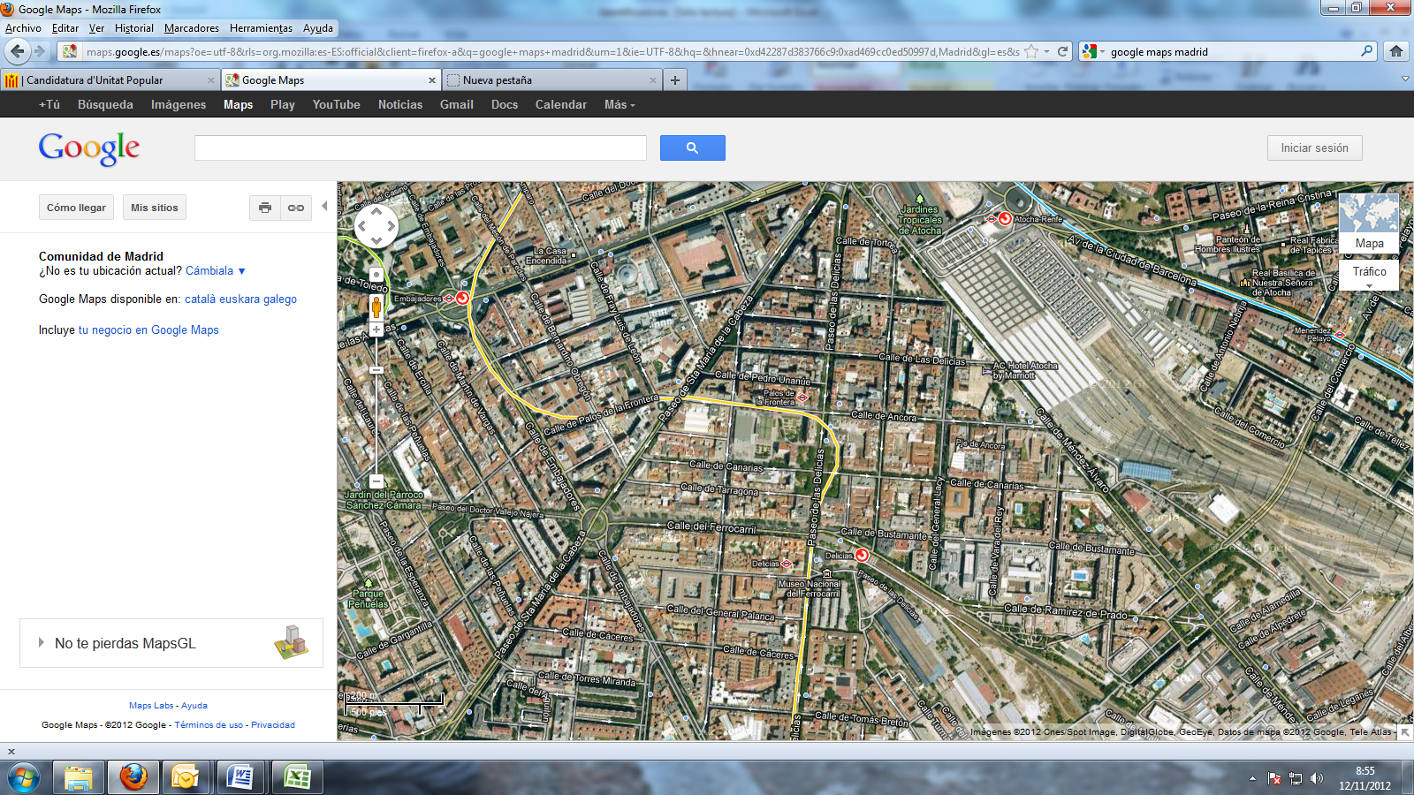

**Madrid-Atocha Train Station**

(Suburban and inter-city trains)

**Puerta de Atocha Train Station**

(High Speed trains AVE)

**Delicias Train Station**

(Suburban trains. Direct to Atocha, Chamartín and Airport T4)

**Madrid Railway Museum and National Museum of Science and Technology buildings**

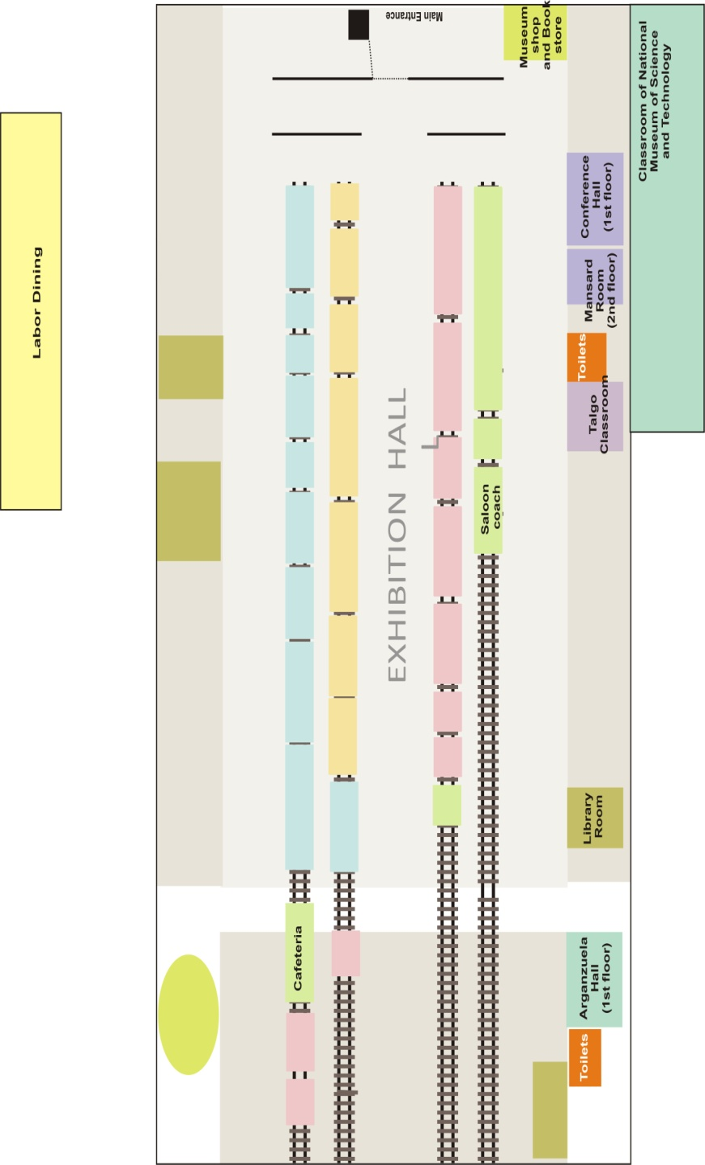

**Bus stops** (Bus lines 8, 19, 45, 47, 59, 85 y 86. Mainly direct to Atocha)

**Delicias underground station**

(Line 3. Direct to Sol)